Lab assignment - 3

DBMS

Question 1 :

SELECT CURRENT_DATE() from product;

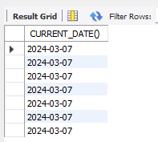

Questrion 2;

SELECT NOW() from product;

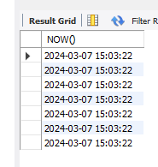

Question 3:

SELECT DATE_FORMAT(NOW(), '%Y-%m-%d %H:%i:%s') AS custom_format;

Question 4:

SELECT DATE_ADD(NOW(), INTERVAL 1 DAY) AS tomorrow;

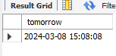

Question 5:

SELECT DATEDIFF('2024-02-10', '2024-02-05') AS date_difference;  


Question 6:

SELECT TIMESTAMPDIFF(MINUTE, '2024-02-05 12:00:00', '2024-02-05 14:30:00') AS minutes_difference;



Question 7:

SELECT STR_TO_DATE('2024-02-05', '%Y-%m-%d') AS converted_date;



Question 8:

SELECT EXTRACT(YEAR FROM '2024-02-05') AS extracted_year;



Question 9:



CREATING TABLES CUSTOMERS AND ORDERS;

CREATE TABLE customers (

customer_numb VARCHAR(5) NOT NULL,

first_name VARCHAR(20),

last_name VARCHAR(20),

PRIMARY KEY (customer_numb)

);

INSERT INTO customers (customer_numb, first_name, last_name)

VALUES ('001', 'Jane', NULL),

('002', 'John', 'Doe'),

('003', 'Jane', 'Smith'),

('004', 'John', 'Jones'),

('005', 'Jane', NULL),

('006', 'John', NULL);

CREATE TABLE orders (

order_numb INT NOT NULL AUTO_INCREMENT,

customer_numb VARCHAR(5) NOT NULL,

order_date DATE,

order_total DECIMAL(10,2),

PRIMARY KEY (order_numb),

FOREIGN KEY (customer_numb) REFERENCES customers(customer_numb)

);

INSERT INTO orders (customer_numb, order_date, order_total)

VALUES ('002', '2009-10-10', 250.85),

('002', '2010-02-21', 125.89),

('003', '2009-11-15', 1567.99),

('004', '2009-11-22', 180.92),

('004', '2009-12-15', 565.00);

Question 10:

SELECT EXTRACT(YEAR FROM order_date) AS year,

EXTRACT(MONTH FROM order_date) AS month,

EXTRACT(DAY FROM order_date) AS day

FROM Orders;  
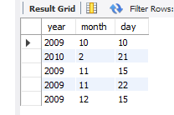

Question 11:

SELECT CONCAT(first_name, ' ', last_name) AS full_name

FROM Customers;

